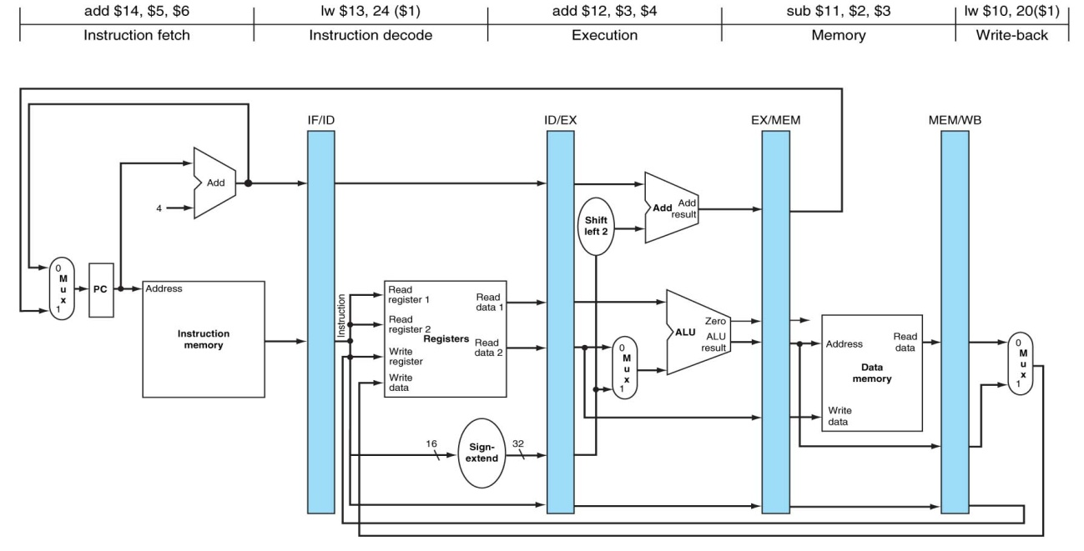

**PLANTILLA PARA EJERCICIOS DE SEGMENTACIÓN:**

|  |  |
| --- | --- |
| **Registro** | **Contenido** |
| **$8** | **3** |
| **$9** | **16** |
| **$10** | **2** |
| **$12** | **1** |

|  |  |
| --- | --- |
| **Posición de memoria** | **Contenido** |
| **[20]** | **200** |
|  |  |
|  |  |
|  |  |

|  |  |
| --- | --- |
| **Método utilizado para resolver los riesgos de datos** | |
| **¿Bloqueo?** | **Sí** |
| **¿Anticipación?** | **Sí** |

|  |  |  |  |  |  |  |  |  |  |
| --- | --- | --- | --- | --- | --- | --- | --- | --- | --- |
| **Registros** | **Ciclo 1** | **Ciclo 2** | **Ciclo 3** | **Ciclo 4** | **Ciclo 5** | **Ciclo 6** | **Ciclo 7** | **Ciclo 8** | **Ciclo 9** |
| **$8** | 3 | 3 | 3 | 3 | 3/200 | 200 | 200 | 200 |  |
| **$11** | x | x | x | x | x | x | x / 202 | 202 |  |
| **$12** | 1 | 1 | 1 | 1 | 1 | 1 | 1 | 1 / 0 |  |
| **EX/MEM** | x | x | x | 20 | 20 | 202 | 0 | 0 |  |
| **MEM/WB** | x | x | x | x | 200 | 200 | 202 | 0 |  |
| **LW $8, 4($9)** | IF (MI) | ID (REG)  ID/EX1 ← $9=16  ID/EX2 ← 4 | EX (ALU)  EX/MEM ← ID/EX1 + ID/EX2  =  16 + 4 = 20 | MEM (MD)  MEM/WEB ← MEM[EX/MEM]  =  MEM[20]  =  200 | WB (REG)  $8 ← MEM/WB = 200 |  |  |  |  |
| **ADD $11, $8, $10** |  | IF (MI) | ID (REG)  ID/EX1 ← $8 = 3  ID/EX2 ← $10 = 2 | ... | EX (ALU)  MEM/WB + ID/EX2  =  200+2 = 202 | MEM (MD)  MEM/WB ← EX/MEM  =  202 | WB (REG)  $11 ← MEM/WB  =  202 |  |  |
| **SUB $12, $12, $12** |  |  | IF (MI) | … | ID (REG)  ID/EX1 ← $12 = 1  ID/EX2 ← $12 = 1 | EX (ALU)  EX/MEM ← ID/EX1 – ID/EX2 = 1 – 1 = 0 | MEM (MD)  MEM/WB ← EX/MEM  =  0 | WB (REG)  $12 ← MEM/WB = 0 |  |
| **Comentarios** |  |  | $8 no contiene el valor deseado |  | Anticipación del valor 200 del registro MEM/WB |  |  |  |  |